

**The information contained in this PDF is proprietary to Omnium Mergers and Acquisitions Inc. (Omnium). This information is provided to Business Broker CRM (BBCRM) to aid in setting up Omnium's Website and Buyer Portal. This information is provided for Omnium's benefit and the disclosure of this information to BBCRM is not permission to use this concept for integration into BBCRM’s system.**

# PUBLIC DOMAIN WEBSITE SECURE BUYER PORTAL

(QUALIFIED)

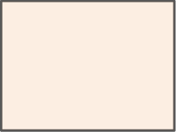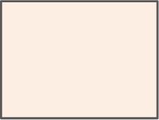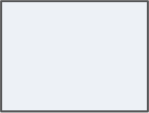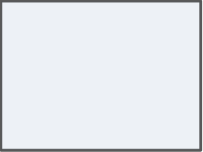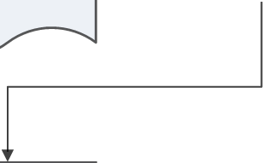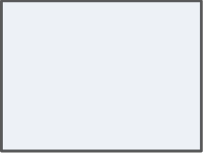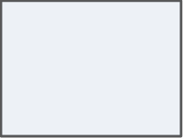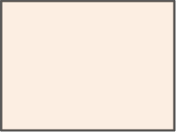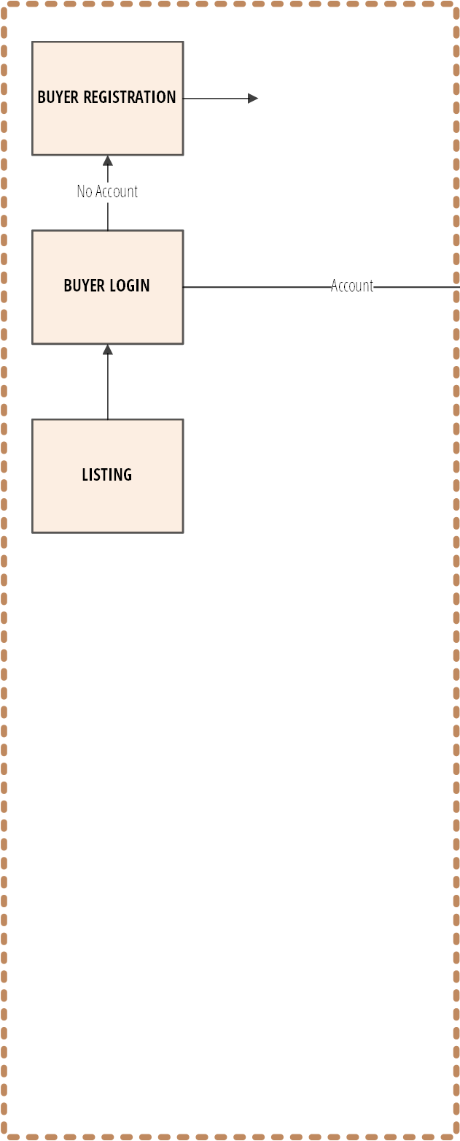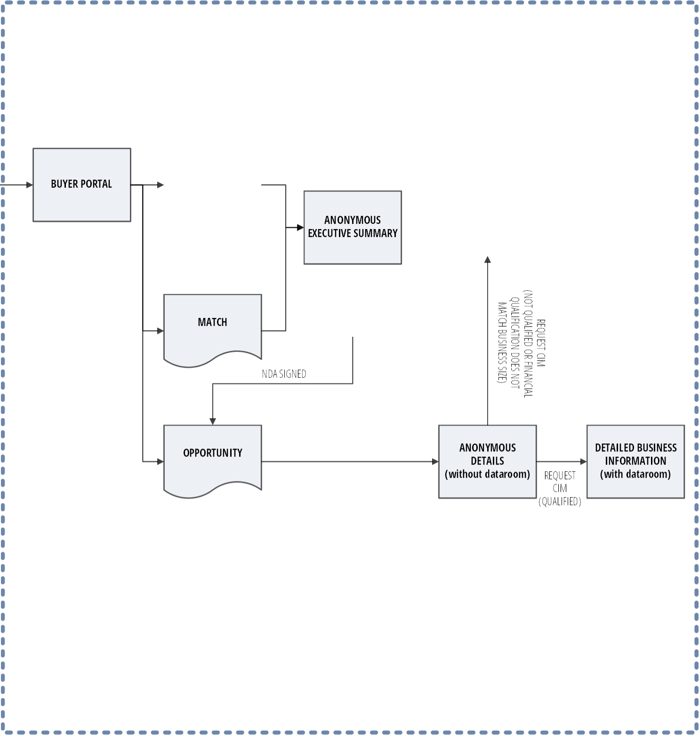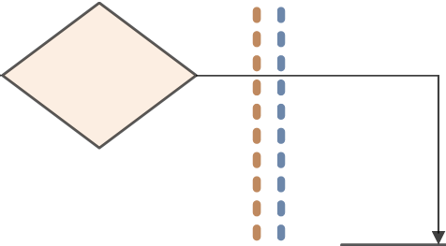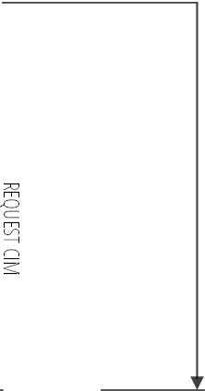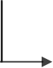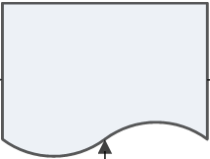

## PHONE VALIDATION

**BUYER REGISTRATION**

No Account

**BUYER LOGIN** Account

**LISTING**

### ONLINE FORM AND CONFIRMATION

THIRD PARTY PERSONAL

ATTESTATION CERTIFICATION

**LISTING**

**BUYER PORTAL**

**ANONYMOUS EXECUTIVE SUMMARY**

**QUALIFICATION**

PROCESS LISTINGS THAT MATCH SEARCH CRITERIA

**NDA**

(N

MQUALOT

A

**MATCH** TCIFIQUALREQ

HC

BATIF UIONIEDUEST SI

NE

SSDOESORCIM

F I

NDA SIGNED S N

I ZNA E

)ONCI

T

A L

**OPPORTUNITY ANONYMOUS DETAILED BUSINESS DETAILS INFORMATION**

**(without dataroom)** REQUEST **(with dataroom)**

CIM

EMAIL WITH NDA CONFIRMATION AND SUGGEST PREQUALIFICATION

**BUYER LOGIN SECTION**

OARD

he landing page after login. mes Buyer by name and gives ats on their use of the

(e.g. # of new matches,

er of opportunities, etc. It also s links to help pages/videos.

company

**Registe**

85%

50%

r. Mandatory fields must eria Tab becomes

15%

ia

to specify parameters for The input in this section will hich businesses would show ATCH section on the left.

0%

85% 50%

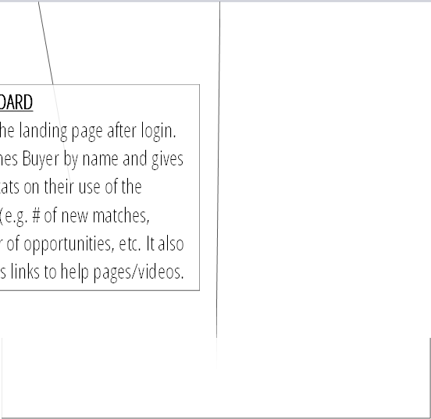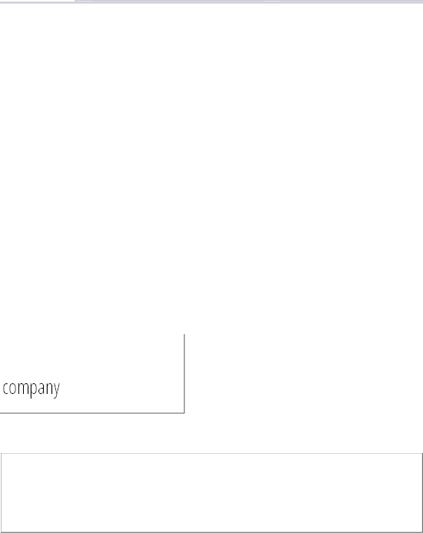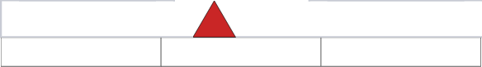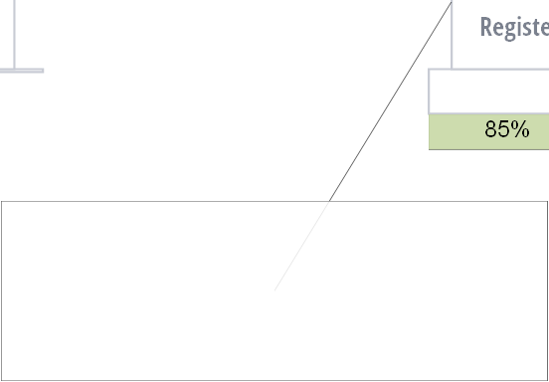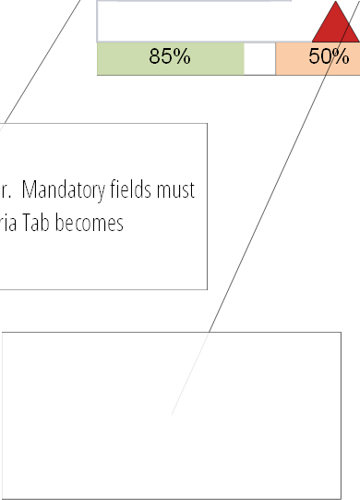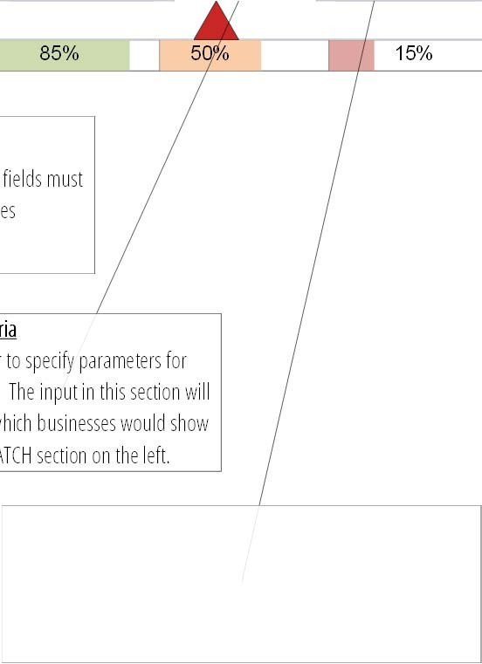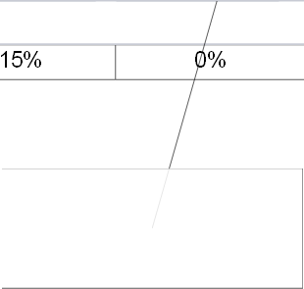

DASHB

This is t Welco some st system numb provide

Register

Basic contact information for the Buye be completed before the Search Crit accessible.

Premium

Future paid service to get early access to opportunities..

LISTING

Shows a list of all the listings for the

OPPORTUNITIES

Shows all the businesses that Buyer has signed an NDA for along with the respective Datarooms for each opportunity

Search Criter Allows buyer their search. determine w up in the M

MATCH

Shows a list of all the listings that match the Search Criteria of the Buyer

Qualified

This exclusive level is accessible only after X # of logins, completion of ALL mandatory field in Registered and Search Criteria and by an automated email invitation sent Y days after completion of the other criteria set forth above.

**Premium**

**Qualified**

**Search Criteria**

**red**

**OPPORTUNITIES**

**MATCH**

**LISTINGS**

**DASHBOARD**

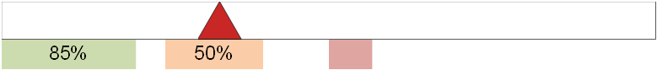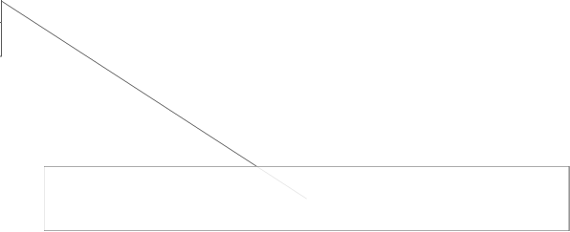

0%

15%

0%

Overall progress and completion percentage of all fields

Progress and completion percentage of all fields within each section

**DASHBOARD**

**DASHBOARD**

**LISTINGS**

**MATCH**

**OPPORTUNITIES**

Hello Azker, welcome back.

**Registered**

**Search**

**Criteria**

85% 50%

|  |  |  |  |  |  |  |  |  |
| --- | --- | --- | --- | --- | --- | --- | --- | --- |
|  | **Registered** |  | **Search**  **Criteria** |  | **Qualified** |  | **Premium** |  |
|  | | | | | | | | |

15% 0%

**Qualified**

**Premium**

**SUMMARY RESEARCH**

LISTINGS MATCHES OPPORTUNITIES

**OPPORTUNITIES**

No. 64

14

4

**6% 28%**

**80%**

1. Valuating a Coffee Shop
2. Best practices for Due Diligence
3. What to expect 1 year after the purchase of a business
4. How to structure a Letter of Intent
5. Do’s and Don’t when buying a business

… MORE

**LEARN**

1. Coffee Shop with Kitchen
2. Truck Repair Business 3, Supplement Distributor

4. High end Mechanic Business

**HISTORY**

1. Coffee Shop with Kitchen
2. Truck Repair Business
3. On-line Gambling Business
4. Thai Restaurant
5. Print Shop on Vancouver Island

**EVENTS**

Manual

Name

Location

Date / TIme

BUYING A BUSINESS 101 SUCCESSFUL DUE DILIGENCE

Date/Time

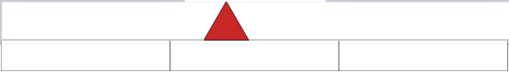

RETAIL BUSINESSES – BOOM or BUST On-line Aug 11, 2021 @ 5pm

BUYING A BUSINESS 101 Surrey June 10, 2021 @ 7pm

Vancouver June 3, 2021 @ 7pm

Vancouver Aug 4, 2021 @ 10am

Register Register Register Register

SUPPORT

**LISTING EXAMPLE**

**DASHBOARD**

**LISTINGS**

**MATCH**

**OPPORTUNITIES**

Hello Azker, welcome back.

**Registered**

**Search**

**Criteria**

85% 50%

|  |  |  |  |  |  |  |  |  |
| --- | --- | --- | --- | --- | --- | --- | --- | --- |
|  | **Registered** |  | **Search**  **Criteria** |  | **Qualified** |  | **Premium** |  |
|  | | | | | | | | |

15% 0%

**Qualified**

**Premium**

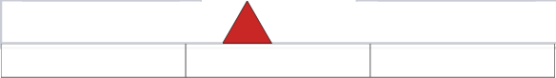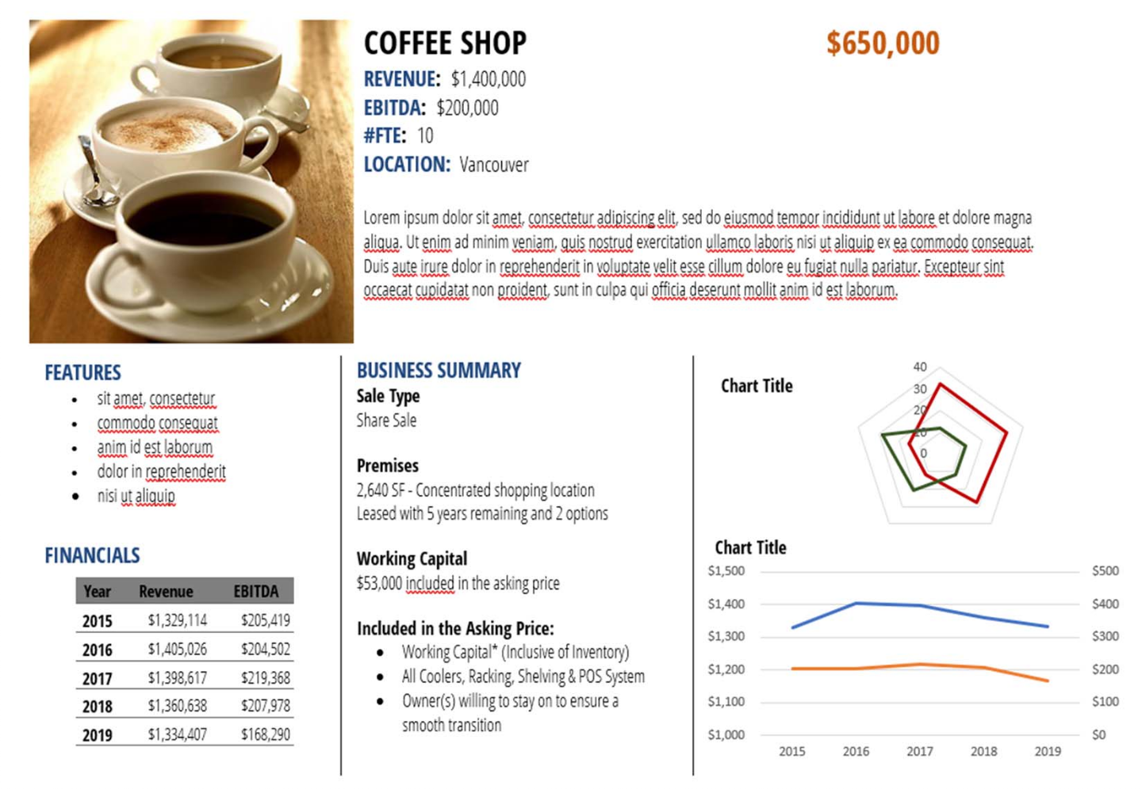

**BUYER STATUS** REGISTERED Complete all the mandatory field in Qualifed section to upgrade your Buyer Status to QUALIFIED.

### MORE INFO

PUBLIC DOMAIN WEBSITE SECURE BUYER LOGIN

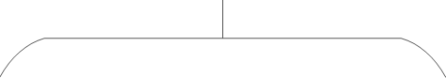

LISTING

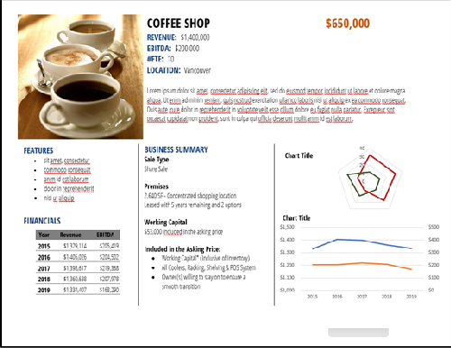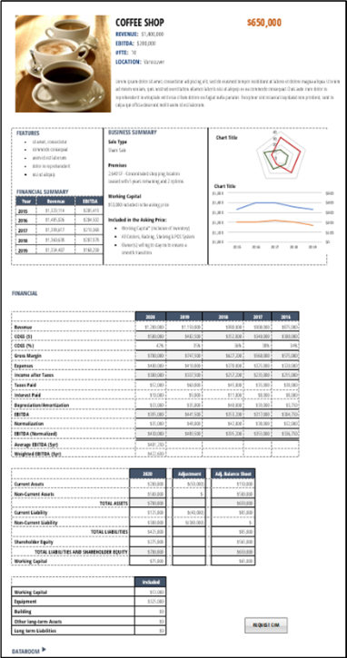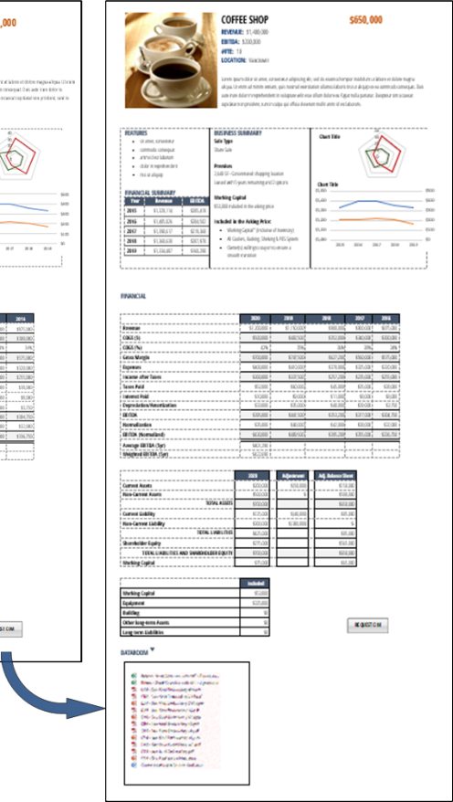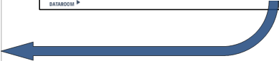

LISTING

OPPORTUNITY

##### GROCERY STORE $333,000

REVENUE: $400,000 EBITDA: $75,000 #FTE: 6 LOCATION: Vancouver

Lorem ipsum dolor sit amet, consectetur adipiscing elit, sed do eiusmod tempor incididunt ut labore et dolore magna aliqua. Ut enim ad minim veniam, quis nostrud exercitation ullamco laboris nisi ut aliquip ex ea commodo consequat. Duis aute irure dolor in reprehenderit in voluptate velit esse cillum dolore eu fugiat nulla pariatur. Excepteur sint occaecat cupidatat non proident, sunt in culpa qui officia deserunt mollit anim id est laborum.

##### BAKERY $500,000

REVENUE: $860,000 EBITDA: $138,000 #FTE: 7 LOCATION: Burnaby

Lorem ipsum dolor sit amet, consectetur adipiscing elit, sed do eiusmod tempor incididunt ut labore et dolore magna aliqua. Ut enim ad minim veniam, quis nostrud exercitation ullamco laboris nisi ut aliquip ex ea commodo consequat. Duis aute irure dolor in reprehenderit in voluptate velit esse cillum dolore eu fugiat nulla pariatur. Excepteur sint occaecat cupidatat non proident, sunt in culpa qui officia deserunt mollit anim id est laborum.

##### COFFEE SHOP $650,000

REVENUE: $1,400,000 EBITDA: $200,000 #FTE: 10 LOCATION: Vancouver

Lorem ipsum dolor sit amet, consectetur adipiscing elit, sed do eiusmod tempor incididunt ut labore et dolore magna aliqua. Ut enim ad minim veniam, quis nostrud exercitation ullamco laboris nisi ut aliquip ex ea commodo consequat. Duis aute irure dolor in reprehenderit in voluptate velit esse cillum dolore eu fugiat nulla pariatur. Excepteur sint occaecat cupidatat non proident, sunt in culpa qui officia deserunt mollit anim id est laborum.

##### TRUCK REPAIR BUSINESS $1,450,000

REVENUE: $2,600,000 EBITDA: $475,000 #FTE: 9 LOCATION: Surrey

Lorem ipsum dolor sit amet, consectetur adipiscing elit, sed do eiusmod tempor incididunt ut labore et dolore magna aliqua. Ut enim ad minim veniam, quis nostrud exercitation ullamco laboris nisi ut aliquip ex ea commodo consequat. Duis aute irure dolor in reprehenderit in voluptate velit esse cillum dolore eu fugiat nulla pariatur. Excepteur sint occaecat cupidatat non proident, sunt in culpa qui officia deserunt mollit anim id est laborum.

##### HIGH END CERAMIC BUSINESS $3,500,000

REVENUE: $5,700,000 EBITDA: $995,000 #FTE: 26 LOCATION: Vancouver

Lorem ipsum dolor sit amet, consectetur adipiscing elit, sed do eiusmod tempor incididunt ut labore et dolore magna aliqua. Ut enim ad minim veniam, quis nostrud exercitation ullamco laboris nisi ut aliquip ex ea commodo consequat. Duis aute irure dolor in reprehenderit in voluptate velit esse cillum dolore eu fugiat nulla pariatur. Excepteur sint occaecat cupidatat non proident, sunt in culpa qui officia deserunt mollit anim id est laborum.

##### GROCERY STORE $333,000

REVENUE: $400,000 EBITDA: $75,000 #FTE: 6 LOCATION: Vancouver

Lorem ipsum dolor sit amet, consectetur adipiscing elit, sed do eiusmod tempor incididunt ut labore et dolore magna aliqua. Ut enim ad minim veniam, quis nostrud exercitation ullamco laboris nisi ut aliquip ex ea commodo consequat. Duis aute irure dolor in reprehenderit in voluptate velit esse cillum dolore eu fugiat nulla pariatur. Excepteur sint occaecat cupidatat non proident, sunt in culpa qui officia deserunt mollit anim id est laborum.

##### BAKERY $500,000

REVENUE: $860,000 EBITDA: $138,000 #FTE: 7 LOCATION: Burnaby

Lorem ipsum dolor sit amet, consectetur adipiscing elit, sed do eiusmod tempor incididunt ut labore et dolore magna aliqua. Ut enim ad minim veniam, quis nostrud exercitation ullamco laboris nisi ut aliquip ex ea commodo consequat. Duis aute irure dolor in reprehenderit in voluptate velit esse cillum dolore eu fugiat nulla pariatur. Excepteur sint occaecat cupidatat non proident, sunt in culpa qui officia deserunt mollit anim id est laborum.

##### COFFEE SHOP $650,000

REVENUE: $1,400,000 EBITDA: $200,000 #FTE: 10 LOCATION: Vancouver

Lorem ipsum dolor sit amet, consectetur adipiscing elit, sed do eiusmod tempor incididunt ut labore et dolore magna aliqua. Ut enim ad minim veniam, quis nostrud exercitation ullamco laboris nisi ut aliquip ex ea commodo consequat. Duis aute irure dolor in reprehenderit in voluptate velit esse cillum dolore eu fugiat nulla pariatur. Excepteur sint occaecat cupidatat non proident, sunt in culpa qui officia deserunt mollit anim id est laborum.

##### TRUCK REPAIR BUSINESS $1,450,000

REVENUE: $2,600,000 EBITDA: $475,000 #FTE: 9 LOCATION: Surrey

Lorem ipsum dolor sit amet, consectetur adipiscing elit, sed do eiusmod tempor incididunt ut labore et dolore magna aliqua. Ut enim ad minim veniam, quis nostrud exercitation ullamco laboris nisi ut aliquip ex ea commodo consequat. Duis aute irure dolor in reprehenderit in voluptate velit esse cillum dolore eu fugiat nulla pariatur. Excepteur sint occaecat cupidatat non proident, sunt in culpa qui officia deserunt mollit anim id est laborum.

##### HIGH END CERAMIC BUSINESS $3,500,000

REVENUE: $5,700,000 EBITDA: $995,000 #FTE: 26 LOCATION: Vancouver

Lorem ipsum dolor sit amet, consectetur adipiscing elit, sed do eiusmod tempor incididunt ut labore et dolore magna aliqua. Ut enim ad minim veniam, quis nostrud exercitation ullamco laboris nisi ut aliquip ex ea commodo consequat. Duis aute irure dolor in reprehenderit in voluptate velit esse cillum dolore eu fugiat nulla pariatur. Excepteur sint occaecat cupidatat non proident, sunt in culpa qui officia deserunt mollit anim id est laborum.

##### BAKERY $500,000

REVENUE: $860,000 EBITDA: $138,000 #FTE: 7 LOCATION: Burnaby



MATCH

**GROCERY STORE**

**$333,000**

REVENUE: $400,000 EBITDA: $75,000 #FTE: 6 LOCATION: Vancouver

Lorem ipsum dolor sit amet, consectetur adipiscing elit, sed do eiusmod tempor incididunt ut labore et dolore magna aliqua. Ut enim ad minim veniam, quis nostrud exercitation ullamco laboris nisi ut aliquip ex ea commodo consequat. Duis aute irure dolor in reprehenderit in voluptate velit esse cillum dolore eu fugiat nulla pariatur. Excepteur sint occaecat cupidatat non proident, sunt in culpa qui officia deserunt mollit anim id est laborum.

**BAKERY**

**$500,000**

REVENUE: $860,000 EBITDA: $138,000 #FTE: 7 LOCATION: Burnaby

Lorem ipsum dolor sit amet, consectetur adipiscing elit, sed do eiusmod tempor incididunt ut labore et dolore magna aliqua. Ut enim ad minim veniam, quis nostrud exercitation ullamco laboris nisi ut aliquip ex ea commodo consequat. Duis aute irure dolor in reprehenderit in voluptate velit esse cillum dolore eu fugiat nulla pariatur. Excepteur sint occaecat cupidatat non proident, sunt in culpa qui officia deserunt mollit anim id est laborum.

**TRUCK REPAIR BUSINESS**

**$1,450,000**

REVENUE: $2,600,000 EBITDA: $475,000 #FTE: 9 LOCATION: Surrey

Lorem ipsum dolor sit amet, consectetur adipiscing elit, sed do eiusmod tempor incididunt ut labore et dolore magna aliqua. Ut enim ad minim veniam, quis nostrud exercitation ullamco laboris nisi ut aliquip ex ea commodo consequat. Duis aute irure dolor in reprehenderit in voluptate velit esse cillum dolore eu fugiat nulla pariatur. Excepteur sint occaecat cupidatat non proident, sunt in culpa qui officia deserunt mollit anim id est laborum.

**HIGH END CERAMIC BUSINESS**

**$3,500,000**

REVENUE: $5,700,000 EBITDA: $995,000 #FTE: 26 LOCATION: Vancouver

Lorem ipsum dolor sit amet, consectetur adipiscing elit, sed do eiusmod tempor incididunt ut labore et dolore magna aliqua. Ut enim ad minim veniam, quis nostrud exercitation ullamco laboris nisi ut aliquip ex ea commodo consequat. Duis aute irure dolor in reprehenderit in voluptate velit esse cillum dolore eu fugiat nulla pariatur. Excepteur sint occaecat cupidatat non proident, sunt in culpa qui officia deserunt mollit anim id est laborum.

Lorem ipsum dolor sit amet, consectetur adipiscing elit, sed do eiusmod tempor incididunt ut labore et dolore magna aliqua. Ut enim ad minim veniam, quis nostrud exercitation ullamco laboris nisi ut aliquip ex ea commodo consequat. Duis aute irure dolor in reprehenderit in voluptate velit esse cillum dolore eu fugiat nulla pariatur. Excepteur sint occaecat cupidatat non proident, sunt in culpa qui officia deserunt mollit anim id est laborum.

##### TRUCK REPAIR BUSINESS $1,450,000

REVENUE: $2,600,000 EBITDA: $475,000 #FTE: 9 LOCATION: Surrey

Lorem ipsum dolor sit amet, consectetur adipiscing elit, sed do eiusmod tempor incididunt ut labore et dolore magna aliqua. Ut enim ad minim veniam, quis nostrud exercitation ullamco laboris nisi ut aliquip ex ea commodo consequat. Duis aute irure dolor in reprehenderit in voluptate velit esse cillum dolore eu fugiat nulla pariatur. Excepteur sint occaecat cupidatat non proident, sunt in culpa qui officia deserunt mollit anim id est laborum.

### CLICK

CLICK

CLICK



**BUYER LOGIN**

**USER NAME**

Enter Text

**PASSWORD**

Enter Text

Register for free Buyer Registration and gain access to our Opportunity Management System

**MORE INFO**

## BUYER QUALIFICATION

#### NOT PREQUALIFIED PREQUALIFIED QUALIFIED

**REGISTER - INITIAL**

**REGISTER - COMPLETE**

**SEARCH**

**QUALIFIED**

**M M**

**Geo. Region Geo. Prox. (Km)**

**Industry Description Type Of Business Mgmt Structure**

c_GeographicRegion

c_GeographicProximityKm

CITY-->PROV-->COUNTRY

c_LookingForIndustryDescription

c_LookingForTypeOfBusiness c_LookingForManagementStrucutre

LIST-MULTIPLE LIST-MULTIPLE LIST-MULTIPLE

**Price Range Min. Price Range Max. Revenue Min.**

**Revenue Max.**

**Income Min. Income Max. EBITDA Min.**

**EBITDA Max.**

c_PriceRangeMinimum c_PriceRangeMaximum c_RevenueMinimum

c_RevenueMaximum

c_IncomeMinimum c_IncomeMaximum c_EBITDAMinimum

c_EBITDAMaximum

$

$

$

$

$

$

$

$

**Property w/ Business** c_PropertyForSaleWBusiness

**Mgmt In Place** c_ManagementInPlace

**IP** c_IP

**Unionized** c_Unionized

**Employee Min.** c_EmployeeMinimum

**Employee Max.** c_EmployeeMaximum

**Timing** c_Timing

Y/N/NA Y/N/NA Y/N/NA Y/N/NA NUM NUM LIST

**Prefix**

**First Name**

**Last Name**

c_Prefix firstName

lastName

LIST TEXT

TEXT

**Mobile Phone**

phone2

PHONE

**Email Password**

email c_password

TEXT TEXT

**Prefix**

**First Name**

**Middle Name Last Name Suffix**

c_Prefix firstName

c_MiddleName lastName c_Suffix

LIST TEXT

TEXT TEXT LIST

**Salutation Gender Occupation**

**Title**

c_Salutation c_gender c_CurrentOccupation

c_jobtitle

Default FIRST NAME LIST

TEXT TEXT

**Home Address 1**

**Home Address 2 City**

address address2

city

TEXT TEXT TEXT

**Prov/State Postal/Zip**

**Country**

state

zipcode country

LIST TEXT/AUTO LIST

**Direct Phone**

**Office Phone Mobile Phone Home Phone Fax**

**Email**

**Email 2**

**Linkedin Facebook**

phone c_phone phone2

c_HomePhone c_Fax

email

c_email

linkedin facebook

PHONE PHONE PHONE PHONE PHONE TEXT TEXT LINK LINK

**Contact Preference Password**

c_ContactPreference c_password

LIST-MULTIPLE TEXT

**Own Business?**

**Have Owned Business?**

**Date of First Search Education Level Experience Level**

c_OwnBusiness c_HaveOwnedBusiness

c_WhenDidYouStartLookingForBusiness c_EducationLevel

c_ExperienceLevel

Y/N Y/N

MONTH/YEAR LIST

LIST

**Work Status**

**Filed for Bankruptcy?**

**3rd Party Partner**

**3rd Party Partner Email**

c_WorkStatus c_FiledForBankruptcy c_3rdPartyPartner

c_Emailof3rdParty

LIST

Y/N Y/N EMAIL

**M M M M**

**M M**

**M M M**

**M M M**

**M M**

**M M M**

**M M**

**Maximum Down Payment Source Of Down Payment Down Payment Ready Today?**

c_amountofdownpayment c_sourceofdownpayment

c_downpaymentavailabletoday

$ LIST

Y/N

**Source Of Balance**

c_sourceofdownpaymentbalance

LIST-MULTIPLE

**M**

**M M**

**M M M**

**M M**

**Strategic/Entrep.**

c_StrategicEntrepreneurial

S/E

**Entrepreneurial Professional Experience Monthly Income**

**Total Assets Total Liabilities**

c_professionalexperience c_monthlyincome c_totalassets

c_totalliabilities

PARAGRAPH

$

$

$

**Strategic Revenue COGS**

**Expenses Income**

c_strategicrevenue c_strategicCOGS

c_strategicexpenses c_strategicincome

$

$

$

$

**Current Assets NC Assets**

**Current Liability NC Liability**

c_strategiccurrentassets c_strategicnoncurrentassets

#N/A

c_strategiccurrentliability c_strategicnoncurrentliability

$

$

$

$

**Additional Financing**

c_strategicadditionalfinancing

$

**M M M**

**M**

**M M M**

**M M**

**M M**

**M M**

**M M**

**M**

**M M**

|  |  |  |
| --- | --- | --- |
| **Company Name** company TEXT  **Company Industry** c_Company_Industry LIST-MULTIPLE  **Company Address 1** c_BusAddress1 TEXT  **Company Address 2** c_BusAddress2 TEXT  **Company City** c_BusCity TEXT | | |
| **Company Prov/State** | c_BusProv | LIST |
| **Company Postal/Zip** | c_BusPostal | TEXT/AUTO |
| **Company Country** | c_BusCountry | LIST |
| **Company Email** | businessEmail | PHONE |
| **Website** | ? | WEBSITE |
| **Company Revenue** | c_Company_Revenue | LINK |
| **No. Employees** | c_Company_Employees | LINK |
| **Company Owner** | c_Company_Owner | LINK |
| **Company Type** | c_Company_Type | dropdown |
| **Company Industry** | c_Company_Industry | dropdown |

**M M**

#### Sign a certfiication that the information provided in accurate and they understand that decisions with financial consequences could be made based upon the information provided.

|  |  |  |
| --- | --- | --- |
| **Background On Contact** | backgroundInfo | PARAGRAPH |

|  |  |  |  |
| --- | --- | --- | --- |
| **M** | **Do Not Email** | ? | CHECK |
|  | **Do Not Mail** | c_DoNotMail | CHECK |
|  | **Do Not Fax** | c_DoNotFax | CHECK |
|  | **Do Not Call** | ? | CHECK |
|  | **Contact Source** | c_HowHearAboutUs | LIST |

**M Mandatory Fields.**

* All Mandatory field in REGISTER and SEARCH must be filled in before invitation to get QUALIFED
* All Mandatory fields in QUALIFED must be filled in before being Qualifed.

|  |  |  |  |
| --- | --- | --- | --- |
| **M** | **Age** | #N/A | LIST |
|  | **Sex** | #N/A | M/F |
|  | **# in Household** | #N/A | LIST |
|  | **Household Annual Income** | #N/A | LIST |
|  | **Social Media Comfort** | #N/A | 12345 |
|  | **Marital Status** | #N/A | LIST |
|  | **Social Media Used** | #N/A | LIST-MULTIPLE |